**Fuzzy Edge Detection**

**Sliding Window Method**

|  |  |  |
| --- | --- | --- |
| P1 | P2 | P3 |
| P4 | P5 | P6 |
| P7 | P8 | P9 |

In the literature, different kind of solution for fuzzy logic edge detection and one of them is using sliding window method. There are mostly subjection of a set of four pixels part of a 2x2 mask of window and nine pixels part of 3x3 mask ofwindow and twenty five pixels part of 5x5 mask of window of an image to a set of fuzzy conditions which help to find the edges in an image.

|  |  |
| --- | --- |
| P1 | P2 |
| P3 | P4 |

Figure 1: 2x2 and 3x3 mask. Source: Aouthor

In the 2x2 window, there are four inputs and one output membership functions for the fuzzy rule based system and the final output pixel value is calculated by using ‘centroid’ defuzzification method. Triangular membership functions are used both input and output, respectively. Two fuzzy sets represent black and white for inputs and three fuzzy sets are used in output which are white, edge and black as shown in the Figure 2.(All membership functions and range of them are intuitive)

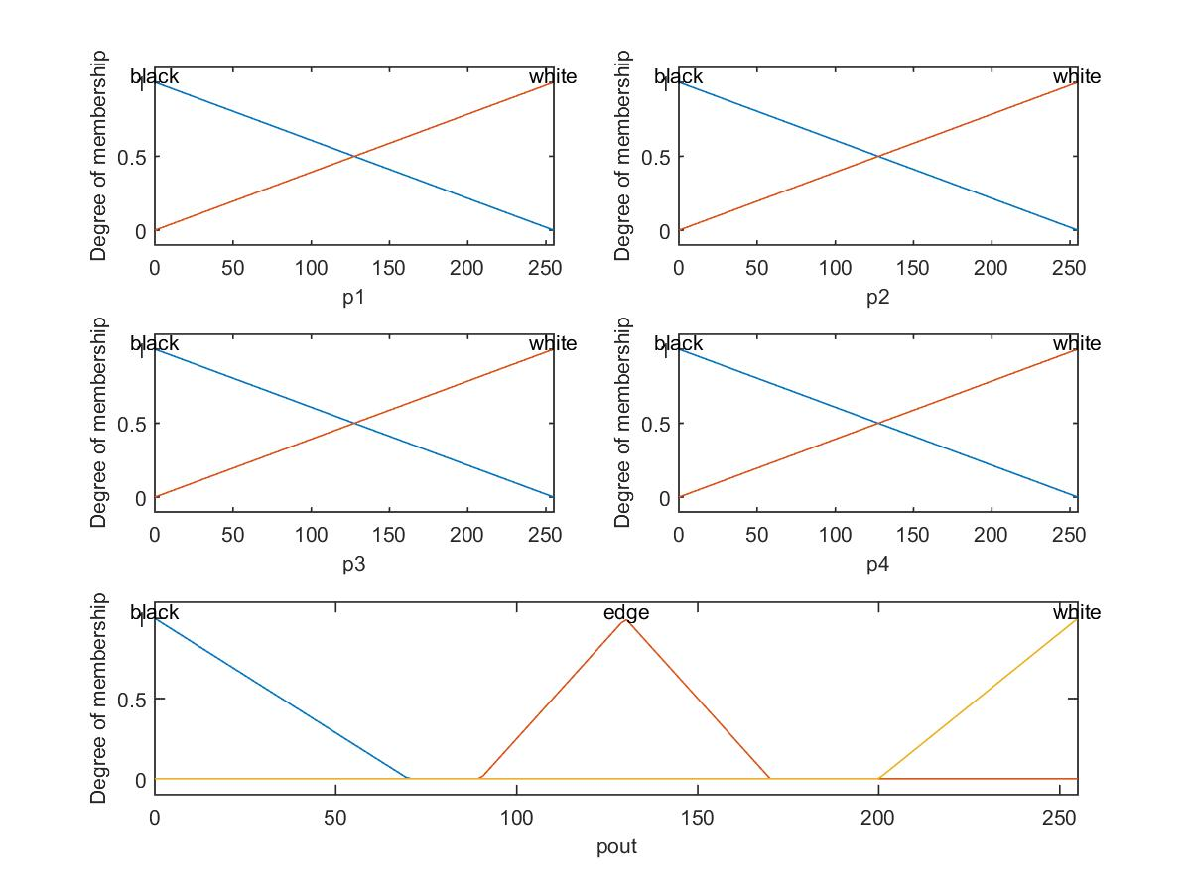

Figure 2: Inputs and Output of the Fuzzy Inference System

After specifiying inputs and output, *IF-THEN* rules must be designed. In the Table 2 inputs and output relations depending on the *IF-THEN* rules are represented.

Table 2: Rule-base

First three rules are below.

*1. If (p1 is black) and (p2 is black) and (p3 is black) and (p4 is black) then (pout is black) (1) 2. If (p1 is black) and (p2 is black) and (p3 is black) and (p4 is white) then (pout is edge) (1) 3. If (p1 is black) and (p2 is black) and (p3 is white) and (p4 is black) then (pout is edge) (1)*

As a final process, computing the first derivative and threshold it to get the edge of the image. Input and output image(which is obtained from applied threshold value) are shown below Figure 3.

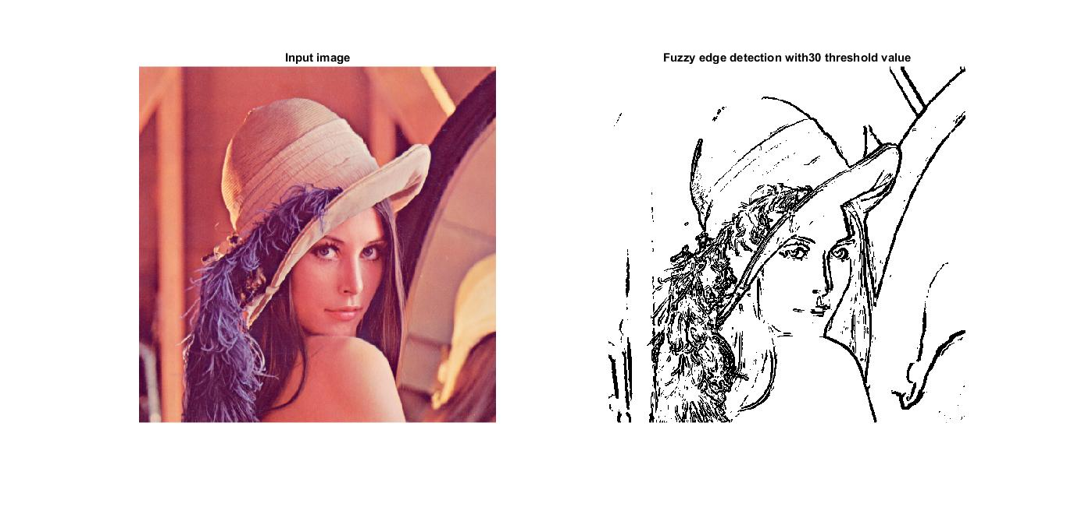

Figure 3: Input and Output Image

|  |  |  |  |  |
| --- | --- | --- | --- | --- |
| Inputs | | | | Output |
| P1 | P2 | P3 | P4 | Pout |
| B | B | B | B | B |
| B | B | B | W | B |
| B | B | W | B | E |
| B | B | W | W | E |
| B | W | B | B | B |
| B | W | B | W | E |
| B | W | W | B | E |
| B | W | W | W | W |

|  |  |  |  |  |
| --- | --- | --- | --- | --- |
| Inputs | | | | Output |
| P1 | P2 | P3 | P4 | Pout |
| W | B | B | B | B |
| W | B | B | W | E |
| W | B | W | B | E |
| W | B | W | W | W |
| W | W | B | B | E |
| W | W | B | W | W |
| W | W | W | B | W |
| W | W | W | W | W |

**References:**

For more details about sliding window, you can search below papers:

**2x2 sliding window**

Aijaz Ur Rahman khan, Dr. Kavita Thakur, “*An Efficient Fuzzy Logic Based Edge Detection Algorithm for Gray Scale Image*”, International Journal of Emerging Technology and Advanced Engineering, Volume 2, Issue 8, August 2012

**3x3 sliding window**

Abdallah A. Alshennawy, and Ayman A. Aly, “*Edge Detection in Digital Images Using Fuzzy Logic Technique*”, World Academy of Science, Engineering and Technology 53 2009,

**5x5 sliding window**

Er.Mandeep Singh Sandhu, Er.Vikram Mutneja, Er.Nishi [2011], “*Image Edge Detection by Using Rule Based Fuzzy Classifier*”, Mandeep Singh Sandhu et al, / (IJCSIT) International Journal of Computer Science and Information Technologies, Vol. 2 (5) , 2011, 2434-2439